DATA ANALYTICS AND VISUALIZATION
3. Time Series
Overview of Time Series Analysis Box-Jenkins Methodology, ARIMA Model Autocorrelation Function (ACF), Autoregressive Models, Moving Average Models, ARMA and ARIMA Models, Building and Evaluating an ARIMA Model, Reasons to Choose and Cautions.
PAST QUESTIONS:
- Why use autocorrelation instead of autocovariance when examining stationary time series? (M23)
- How does the ARMA model differ from the ARIMA model? In what situation is the ARMA model appropriate? (M23)
- Box-Jenkins Methodology. (M23, M24, D24)
- Explain Box-Jenkins intervention analysis. (D23)
- Time series analysis. (D23)
- Explain components of time series? (M24)
- Explain ARIMA model in detail. Also state its Pros and Cons. (M24)
- What is time series analysis? Explain its components. (D24)
- Explain Autoregressive (AR), Moving Average (MA), Autoregressive Moving Average (ARMA) and Autoregressive Integrated Moving Average (ARIMA) Models in detail. (D24)

NOTES:

*Time Series Analysis :-
Time series analysis in data analytics refers to the process of analyzing data points that are collected or recorded at specific time intervals. This technique helps to understand underlying patterns, trends, and seasonality in the data, and it is often used for forecasting future values. It helps businesses make informed decisions, optimize resources, and mitigate risks by anticipating market demand, sales fluctuations, stock prices, and more.
Components of Time Series –
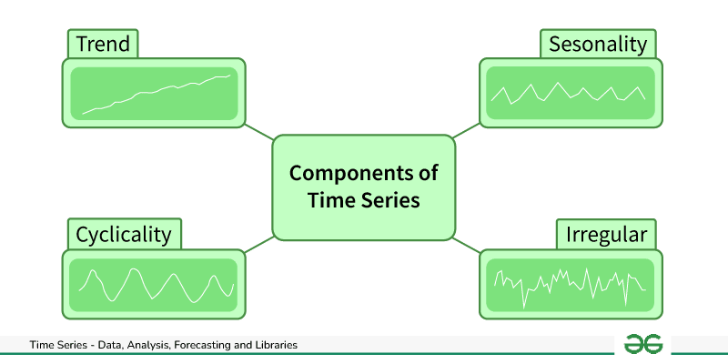
- Trend: The long-term movement in the data (upward, downward, or flat). It shows the general direction in which the data is heading over time.
- Seasonality: The repeating short-term cycle in the data. For example, retail sales may peak during holidays each year.
- Cyclicality: Long-term fluctuations or cycles in the data that are not seasonal but may occur due to economic conditions, business cycles, etc.
- Irregularity: Random variability in the data that cannot be explained by trends, seasonality, or cyclic behaviour.
* Box-Jenkins Methodology :-
Box-Jenkins method is a type of forecasting and analyzing methodology for time series data. Box-Jenkins method comprises of three stages through which time series analysis could be performed. It comprises of different steps including identification, estimation, diagnostic checking, model refinement and forecasting.
The Box-Jenkins method is an iterative process, and steps 1 to 4 from identification to model refinement are often repeated until a suitable and well-diagnosed model is obtained.

1. Model Identification - Identification is the first step of Box-Jenkins method it helps in determining the orders of autoregressive (AR), differencing (I), and moving average (MA) components that are appropriate for a given time series. This step helps in identifying the values of p, d and q for the given time series.
2. Parameter Estimation - Estimation is the second stage in the Box-Jenkins methodology for ARIMA modeling. In this stage, the identified ARIMA model parameters, including the autoregressive (AR), differencing (I), and moving average (MA) components, are estimated based on historical time series data. The primary goal is to fit the chosen ARIMA model to the observed data.
3. Diagnostic Checking - Diagnostic checking is an important step in the Box-Jenkins methodology for ARIMA modeling. It involves evaluating the acceptance of the fitted ARIMA model by examining the residuals. The goal is to ensure that the residuals are random and do not contain any patterns or structure.
4. Model Refinement - The model refinement stage in the Box-Jenkins method involves a thorough evaluation of the estimated ARIMA model to ensure that it meets the required statistical assumptions and adequately captures the patterns in the time series data.
5. Forecasting - Generate forecasts: Use the fitted model to forecast future values.

*Autocorrelation and Autocovariance :-
Autocorrelation is a measure of the similarity between a time series and a lagged version of itself over successive time intervals. It shows how the data at one time point is correlated with the data at another time point.
Autocovariance is similar to autocorrelation, but instead of normalizing by the variance, it measures the absolute covariance between a time series and its lagged version.

*Autoregressive (AR) :-
Autoregressive models (AR models) are a concept in time series analysis and forecasting that captures the relationship between observations. Its idea is that the current value of a time series data can be expressed as a linear combination of its past values with some random noise.
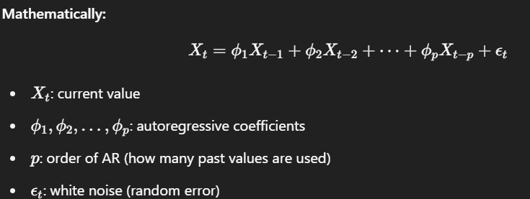
Example use: If the temperature today depends on the temperatures of the past few days or months, an AR model would be suitable.

*Moving Average (MA) :-
Moving Average Models are a type of time series analysis model usually used in econometrics to forecast trends and understand patterns in time series data. It predicts the current value based on past forecast errors (residuals).
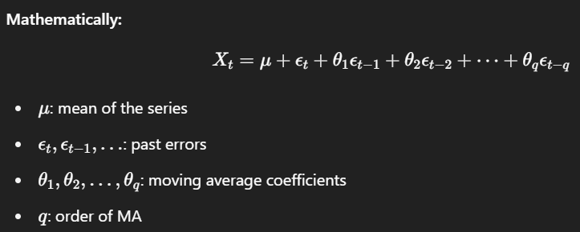
Example use: If recent shocks or noise (unexpected temperature changes) influence the current reading, MA captures that effect.

*Autoregressive Moving Average (ARMA) :-
The ARMA model is a combination of two simpler models: the Autoregressive (AR) model and the Moving Average (MA) model.
The ARMA model is used to describe time series data that is stationary, meaning its statistical properties do not change over time.
ARMA components -
- Autoregressive (AR) Model: This model uses the dependency between an observation and a number of lagged observations (previous time points). It is denoted as AR(p), where p is the number of lagged observations included.
- Moving Average (MA) Model: This model uses the dependency between an observation and a residual error from a moving average model applied to lagged observations. It is denoted as MA(q), where, q is the number of lagged forecast errors included.
Determining the appropriate values for p and q is crucial for building an effective ARMA model. This can be done using the following methods:
- Partial Autocorrelation Function (PACF):
  - PACF is used to determine the order p of the AR model. It measures the correlation between observations at different lags, excluding the influence of intermediate lags.
- Autocorrelation Function (ACF):
  - ACF is used to determine the order q of the MA model. It measures the correlation between observations at different lags.
Pros –
- The ARMA model is relatively simple to understand and implement.
- Performs well when the data is stationary.
- Captures both autocorrelation (AR) and error correction (MA) behaviour in one model.
- ARMA models are often accurate for short-term predictions, especially when conditions are stable and patterns repeat.
Cons –
- Only works on stationary data.
- Choosing the right order for the AR and MA components can be challenging.
- The model becomes complex with high parameters.
- ARMA cannot handle trends or seasonal effects.

*Autoregressive Integrated Moving Average (ARIMA) :-
ARIMA, standing for Autoregressive Integrated Moving Average, is a widely used statistical method for time series forecasting. It's especially useful when the data is non-stationary, meaning its statistical properties change over time.
It combines three key components to model data:
- Autoregression (AR): This component relates the present value to its past values through a regression equation.
- Differencing (I for Integrated): It involves differencing the time series data to make it stationary, ensuring that the mean and variance are constant over time.
- Moving Average (MA): This component uses the dependency between an observation and a residual error from a moving average model applied to lagged observations.
The ARIMA model is defined by three main parameters: p, d, and q.
- p (AR order): Represents the number of autoregressive terms and is denoted by p. It refers to the number of past observations that directly influence the current value.
- d (Differencing order): Represents the number of differences needed to make the time series stationary. It involves computing the differences between consecutive observations.
- q (MA order): Denoted by q, it represents the number of lagged forecast errors in the prediction equation.
Pros –
- Can handle non-stationary time series.
- Works well for data with trend.
- Simple, interpretable, and widely supported.
Cons –
- Does not handle seasonality.
- Assumes linear relationships.
- Choosing correct parameters p, d and q can be complex.

*ARMA vs ARIMA :-
